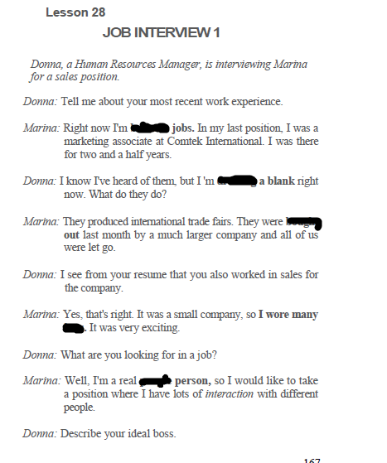

**between , people , hats , drawing , bought,**

**between, drawing, bought, hats, people**



hands , micro , foot , spark, put , stepping, outside ,

hands, micro, outside, put, spark, stepping, foot

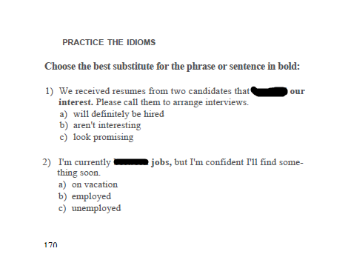

1. spark, c

2. between, c

3. people, a

4. hats, c

5. foot, a

6. drawing, b

7. stone, a

8. hands, b

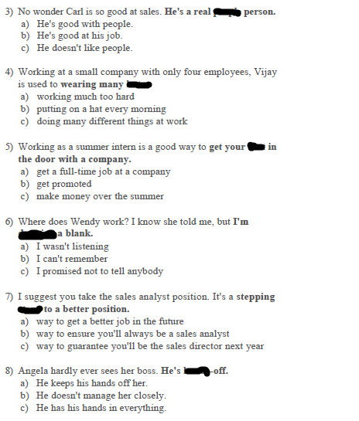

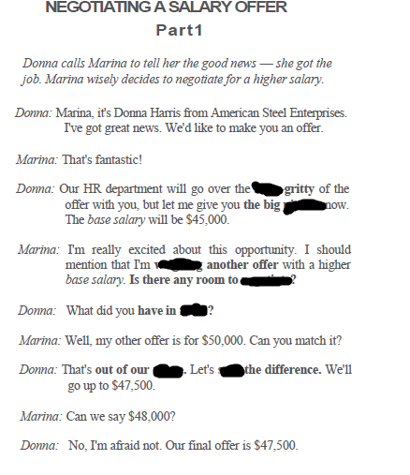

**nitty , picture, weigh , split , mind, negotiate , range**

**nitty, picture, weighing, negotiate, mind, range, split**

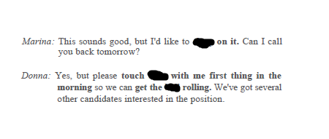

**ball , sleep , base**

**sleep, base, ball**

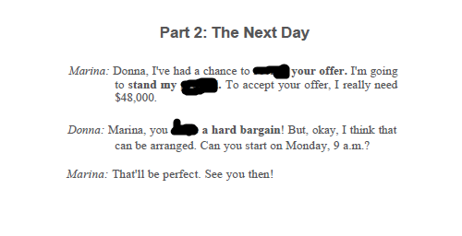

**review , ground , drive**

**review, ground, drive**

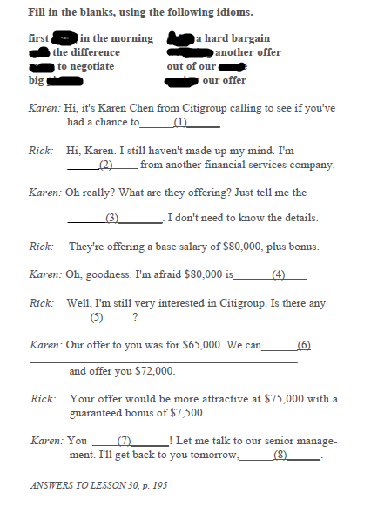

1. review our offer

2. weighing another offer

3. big picture

4. out of our range

5. room to negotiate

6. split the difference

7. drive a hard bargain

8. first thing in the morning